**PRACTICAL-6**

**AIM:**

Demonstrate the static and dynamic configuration of NAT using cisco packet tracer

**THEORY:**

* NAT stands for “Network Address Translation”.
* A Network Address Translation (NAT) is the process of mapping an internet protocol (IP) address to another by changing the header of IP packets while in transit via a router.

* This helps to improve security and decrease the number of IP addresses an organization needs.
* Usually a firewall, assigns a public address to a computer (or group of computers) inside a private network.
* The most common form of network translation involves a large private network using addresses in a private range
* The private addressing scheme works well for computers that only have to access resources inside the network, like workstations needing access to file servers and printers.
* Routers inside the private network can route traffic between private addresses with no trouble.
* However, to access resources outside the network, like the Internet, these computers have to have a public address in order for responses to their requests to return to them. This is where NAT comes into play.
* It is suitable only for small network.
* If a link fails it cannot reroute the traffic.
* There are three types of address translation.
* Static NAT – translates one private IP address to a public one. The public IP address is always the same.
* Dynamic NAT – private IP addresses are mapped to the pool of public IP addresses.
* Port Address Translation (PAT)– one public IP address is used for all internal devices, but a different port is assigned to each private IP address. Also known as NAT Overload.

**PRACTICAL IMPLEMENTATION:**

**STATIC NAT:**

* Firstly, create a topology shown in the picture below by connecting the devices through appropriate connections.
* For the topology, we will use 2 routers,2 PCs, 1 switch, and 1 server.

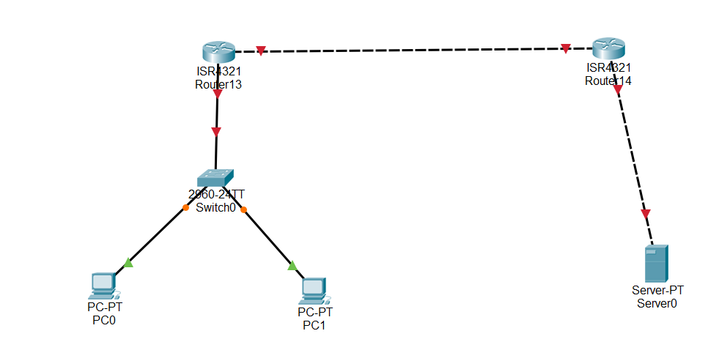

* Now, we will divide the topology into 3 networks.
* Also, we will assign private and public IP addresses to each end devices and gateways.
* Topology will now look like the below image.

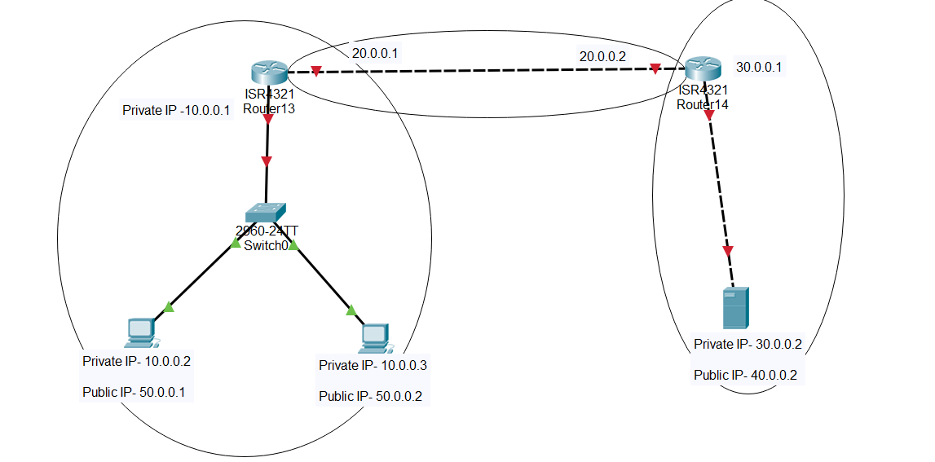

* Now, assign Private IP address to the end devices.
* Steps are: PC -> IP configuration -> Enter the IP address and Gateway.

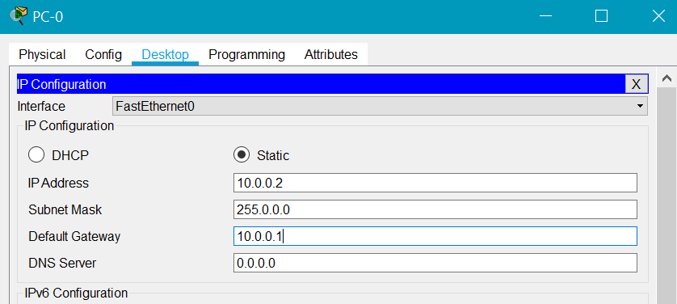

* Perform the same steps for all the PCs.
* In server services, we will select the HTTP option.

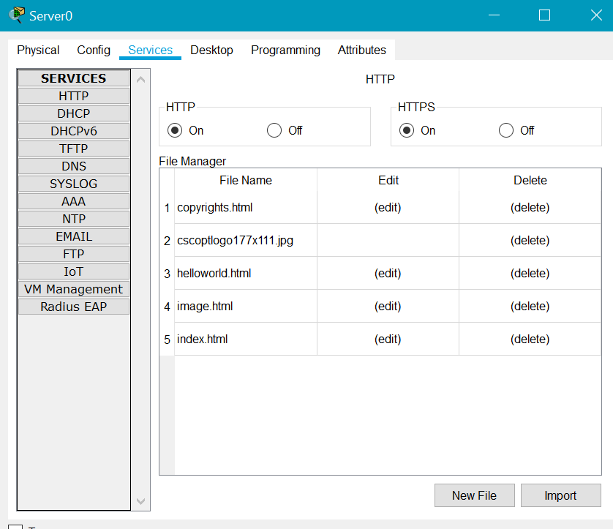

* Now, make some changes in index.html.

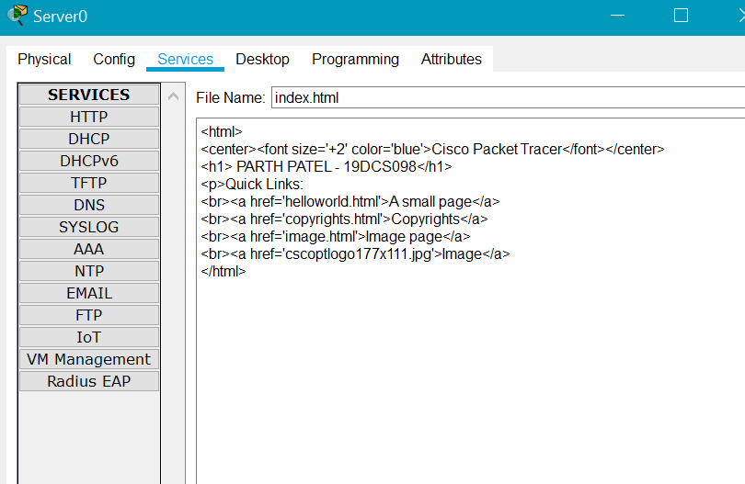

* Now, configure the router.
* This time, we will use config mode instead of CLI mode.
* For this method, Go to Config tab -> enter the IP address and check the On option.

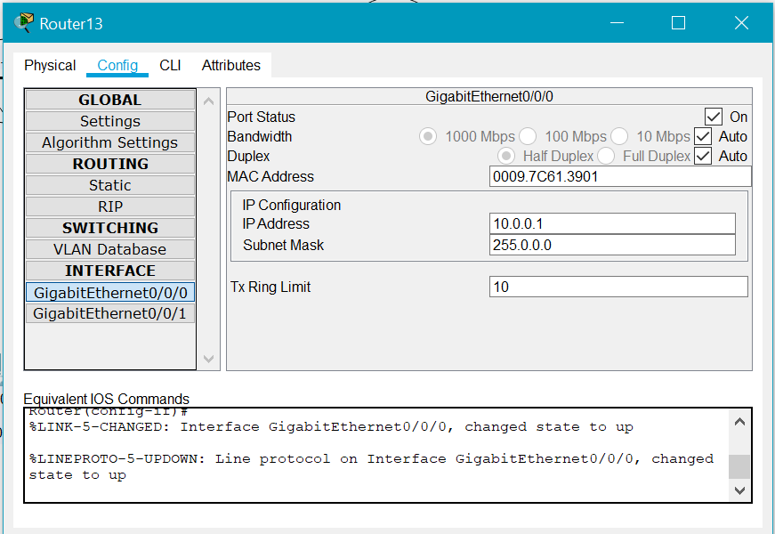

* Perform the same steps for all the connections.
* Upon successful connection establishment, the Topology will look like the below image.

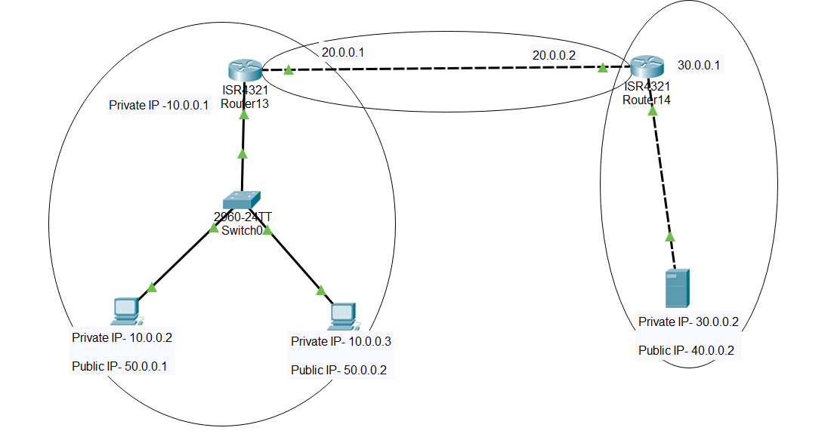

* Now, we will do the mapping of private and public IP address in Router.
* The above step will enable the router to know which public IP is mapped to its corresponding private IP.

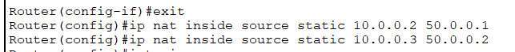

* This will let the router know the mappings of public and private IP.



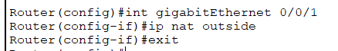

* Follow the same steps for other router.
* Now we will do static routing configuration.

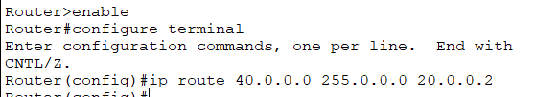

* Perform the similar steps in other router.

**NETWORK TESTING:**

**PING TEST:**

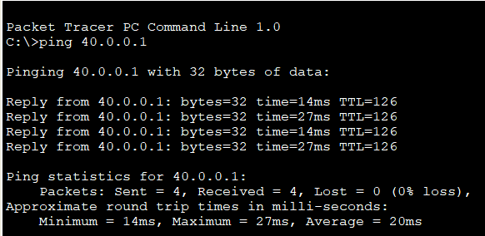

**We can ping the server using public IP address**

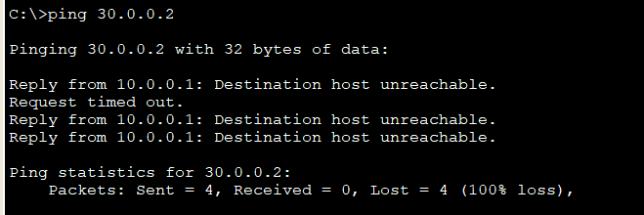

**We cannot ping the server using private IP address.**

**TESTING USING BROWSER:**

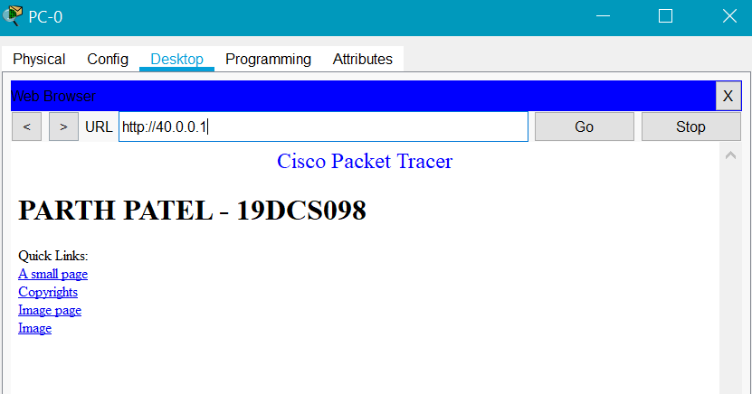

**We can access index.html through public IP address**

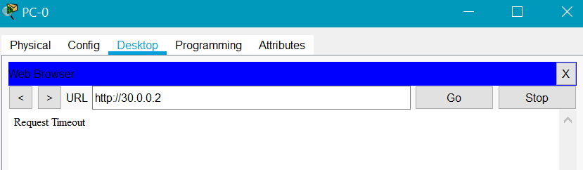

**We cannot access index.html with private IP address.**

**DYNAMIC NAT:**

* FOR DYNAMIC NAT, we will keep the same topology.
* So, first, we need to follow the same steps till the configuration of router.
* Now, after configuring the connection, the topology will be like the image below.

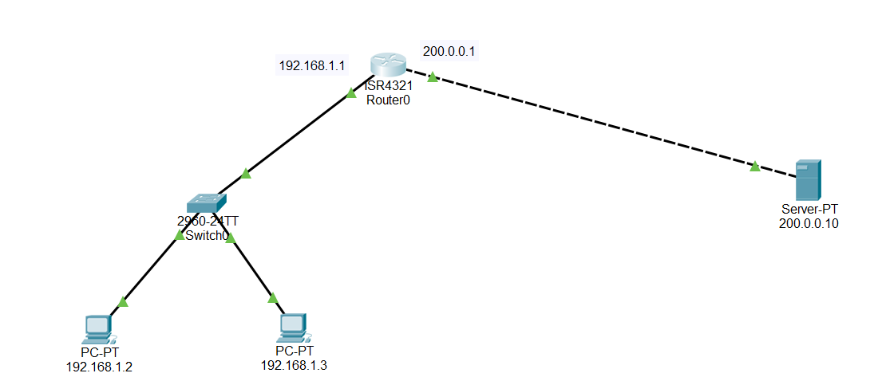

* Now, follow the below steps for Dynamic NAT configuration.





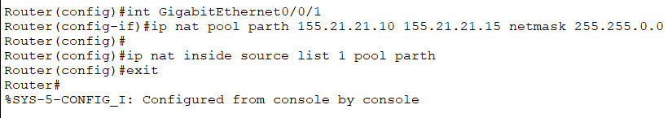

* To verify the configuration, perform the below mentioned steps

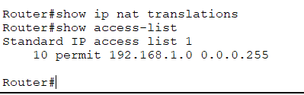

**NETWORK TESTING:**

**PING TEST:**

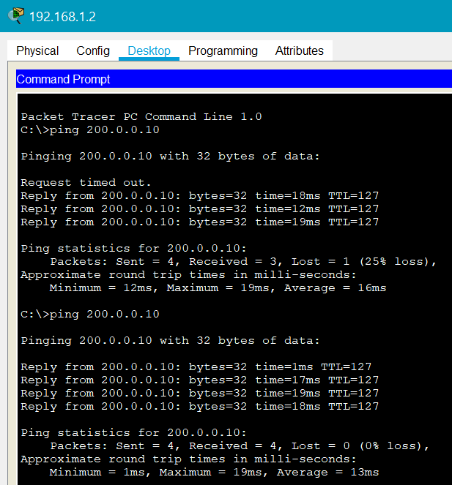

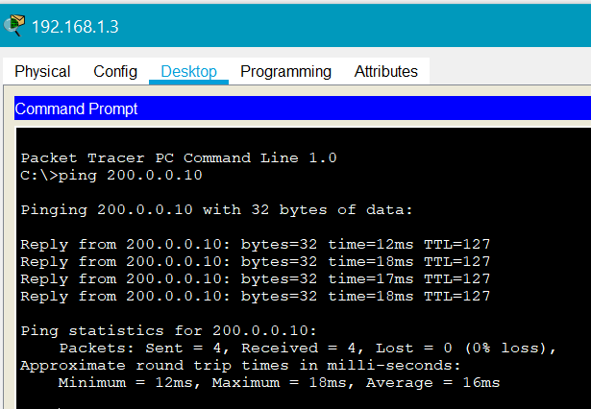

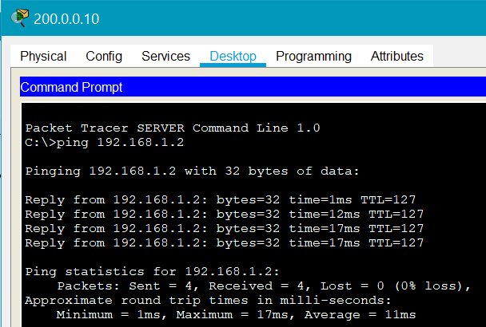

**TESTING THROUGH WEB BROWSER:**

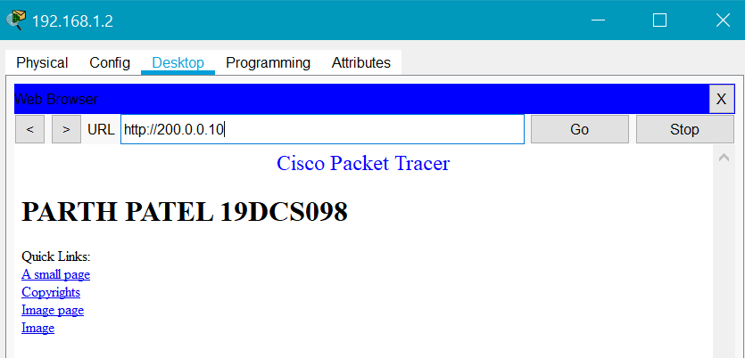

**CONCLUSION:**

* By performing the above practical, we learned the concept of NAT.
* We also learned the types of NAT.
* We also learned how to configure the network using STATIC NAT and DYNAMIC NAT.